Simulation, Testing and Feasibility Study

A. Scope of the Evidence
The evidence presented in this section is of two kinds, and they are kept apart deliberately because they support different claims.
The first is algorithmic simulation evidence: a controlled comparison of controller variants over a fixed scenario set, in a simulated plant, driven by synthetic tremor. This establishes whether the control architecture works, and it is the evidence against which the delivered controller was designed and tuned.
The second is public real-data evidence: analysis of recordings made from human subjects by other researchers and released publicly. It is used in two distinct ways — to test the surface electromyography (sEMG) assumptions the fusion rests on, and to replace the synthetic tremor input with a recorded one.
There is no hardware tier. No physical prototype was built, no bench measurement was taken, and no human subject was recorded for this project. Every actuator, coil and flexure parameter is a manufacturer data-sheet value applied to a structure that was never manufactured. The claim this work is entitled to make is therefore bounded, and is stated here in the form used throughout:
The control algorithm was validated in simulation, and public real-data analysis was used both to test the sEMG assumptions it rests on and to drive the plant with recorded human tremor. Physical closed-loop human validation was outside the scope of this project.
Every result below is reproducible from the repository through a single entry point; the commands are given in Section H.

B. Simulation Environment and Its Verification
The plant is a two-degree-of-freedom gimballed spoon driven by voice-coil actuators through a flexure transmission. The simulation integrates the mechanism kinematics, actuator electrical dynamics, payload inertia and sensor noise at a 0.5 ms mechanical step, with the outer attitude loop at 800 Hz and the inner current loop at 10 kHz.
Three things support treating this model as a usable development baseline. First, the mechanism is verified analytically: rod-closure error is 3.5 × 10⁻¹⁸ m, the Jacobian error 4.5 × 10⁻¹² and the energy-balance residual 3.7 × 10⁻¹² W, so the kinematic and power bookkeeping are exact to numerical precision. Second, the fast fixed-step solver used for the sweeps is checked against a continuous-time Simulink reference on a nominal case, and the two agree to within a small residual in joint angle and suppression. Third, the model is covered by an automated suite of seventeen validation groups — mesh properties, packaging clearances, physics, hardware limits, control behaviour, the estimator, the sEMG front end, the tremor input path and the liquid model — which runs in approximately 80 s and must pass before any result is generated.
What the model does not contain matters equally. There is no hysteresis, no creep and no backlash in the flexure, and no friction model beyond a simple guide term. The plant is therefore an algorithm-development baseline, not a validated digital twin, and absolute performance figures inherit that limitation.

C. Test Protocol and Metric Definitions
The benchmark comprises twenty scenarios spanning four questions: a tremor-frequency sweep at 4, 5, 7, 8, 9, 11 and 12 Hz; tremor waveform and amplitude (a mixed multi-frequency tremor, a chirp, an irregular tremor, and a 3° amplitude case); voluntary motion, both alone and superimposed on tremor; and plant robustness (no payload, 15 g payload, a 5.8 V bus in place of 7.4 V, and a degraded actuator with +20 % coil resistance, −15 % force constant and doubled guide friction).
Tremor suppression is the percentage reduction in attitude RMS relative to a baseline in which the spoon is rigidly attached to the hand and subjected to the identical base input. Scoring begins at t = 1.5 s to exclude the start-up transient, and no scoring filter is applied. Because the metric is referred to an uncontrolled baseline, it is negative when a controller does worse than no control at all — a property retained rather than clipped, because it is diagnostic.
Attitude error RMS is reported alongside, and is the only meaningful metric on the voluntary-motion-only scenario, where there is no tremor to suppress and the suppression percentage is undefined.
Every variant is run over identical scenarios with identical sensor seeds, so the only difference between blocks of results is the variant definition. This makes the comparison a controlled experiment rather than a collection of separately tuned runs.
Hardware feasibility. Three of the twenty scenarios demand more of the actuator than it can supply, judged by an inverse-dynamics bound that assumes perfect knowledge and exact tracking and asks what current, voltage, copper power, travel and side load the input would require. Case 5 (10 Hz, 3°) needs 7.10 V of a 7.4 V bus; case 14 (8 Hz, 5°) needs 7.50 V; case 20 (20 Hz, 1°) needs 1.84 A against a 1.5 A limit, 9.75 V, and 5.28 W against a 4.4 W continuous rating. No controller could have succeeded on these, so scoring them measures the actuator rather than the algorithm. They are excluded from the headline mean, and all three averages — all scored scenarios, feasible scenarios only, and feasible scenarios that also stayed within limits — are always reported together so the exclusion is visible rather than silent.

D. Controller Comparison on Synthetic Tremor
Table I gives the six-variant comparison. The variants differ only in the estimator and in whether the sEMG stream is used; plant, scenarios and seeds are identical throughout.
TABLE I. CONTROLLER COMPARISON, 20 SCENARIOS
Variant | Description | All scored (%) | Feasible (%) | Worst feasible (%) | Voluntary-only error (°) | Meets 90 %
simple_pid | Fixed notch chain (original) | 64.19 | 90.23 | 51.51 | 0.4583 | 15/16
ekf_cv_legacy | First EKF, with the intent-propagation defect | 68.75 | 88.96 | 30.75 | 1.2390 | 11/16
ekf_cv | Corrected EKF, IMU only | 71.03 | 92.12 | 85.88 | 0.2008 | 11/16
ekf_cv_osc2 | As above, plus a second tremor oscillator | 71.04 | 92.13 | 85.90 | 0.2008 | 11/16
ekf_cv_qfix | Ablation: same mechanism, no sEMG | 65.62 | 85.18 | −41.41 | 3.0418 | 15/16
ekf_cv_semg | sEMG + IMU (delivered) | 72.63 | 93.04 | 85.31 | 0.2070 | 15/16

The delivered controller averages 93.04 % tremor suppression over the sixteen feasible scenarios and meets the 90 % design target on fifteen of them, while holding voluntary-motion error to 0.207° against 0.458° for the original controller. This is the result the controller was designed and tuned against, and it is the figure that justified the architecture: it is the first variant that is not a trade-off, matching the original controller on plain tremor, matching the IMU-only estimator on deliberate movement, and beating both on multi-frequency tremor. Fig. 1 gives the scenario-by-scenario comparison.
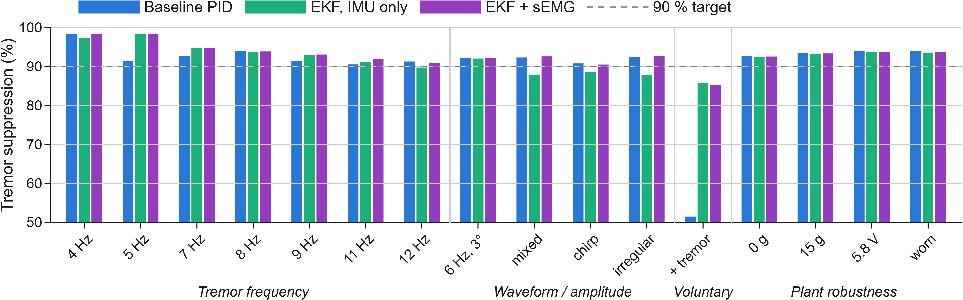
Fig. 1. Tremor suppression across the sixteen hardware-feasible benchmark scenarios, for the original controller, the IMU-only estimator and the delivered sEMG + IMU system, grouped by tremor frequency, waveform and amplitude, voluntary motion, and plant robustness. The dashed line is the 90 % design target. Three scenarios exceeding the actuator's inverse-dynamics feasibility bound, and one carrying no tremor, are excluded.
Two properties of this result matter as much as the headline. First, it is not purchased with actuator effort: peak current across the whole sweep is 1.4320 A for the delivered controller against 1.4305 A for the IMU-only estimator, and peak mean coil power 5.719 W against 5.723 W — differences of about 0.1 %, comfortably inside the thermal and battery budget. A suppression gain bought with extra current would not have survived those limits. Second, the gain is concentrated where the original controller was weakest: on the scenario combining voluntary movement with tremor it collapses to 51.51 %, while the delivered controller holds 85.31 %.

E. Attribution: the Sensor, not the Mechanism
sEMG enters the estimator as a per-axis, per-sample scaling of the process noise assigned to the voluntary-motion state — in effect a confidence signal deciding how freely the estimator may attribute motion to intent. A reasonable objection is that the benefit comes from that scaling and not from the muscle signal at all. The ekf_cv_qfix variant exists to answer it: it applies the identical scaling with the confidence held constant and no muscle signal present.
TABLE II. ABLATION — WHAT THE SENSOR CONTRIBUTES
Measure | Ablation (no sEMG) | sEMG + IMU | Attributable to the sensor
Feasible-case mean (%) | 85.18 | 93.04 | +7.86 points
Movement + tremor (%) | −41.41 | 85.31 | +126.7 points
Voluntary-only error (°) | 3.0418 | 0.2070 | 14.7× lower

The ablation behaves as predicted: holding the confidence at a constant favourable value improves multi-frequency tremor suppression and destroys everything involving deliberate movement. Any gain the delivered controller shows over both the IMU-only estimator and this ablation is therefore attributable to the sEMG stream and to nothing else. Inspecting the estimator confirms the designed mechanism directly: tremor mis-attributed to the voluntary state falls by 2.6× to 3.1× on the multi-frequency scenarios (0.171° → 0.066°, 0.170° → 0.055°, 0.038° → 0.014°) with no loss of movement tracking. Fig. 2 shows both halves of the trade.
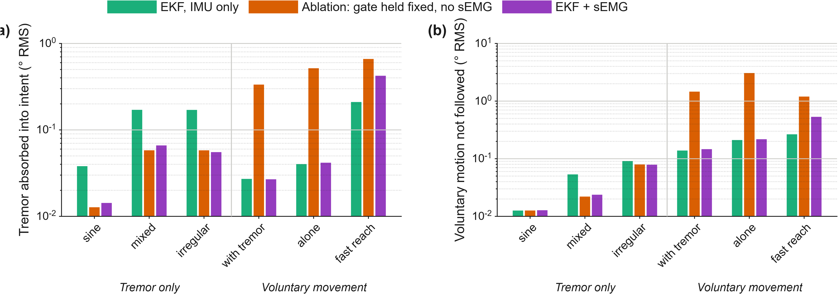
Fig. 2. The sEMG ablation. (a) Tremor mis-attributed to the voluntary-motion state. (b) Voluntary motion the estimator failed to follow. The ablation applies the identical process-noise scaling with no muscle signal present; it wins the left panel and loses the right one, which is the trade the sensor exists to break. Logarithmic ordinates; lower is better in both panels.

F. Limitations Identified by Testing
Three tests were run specifically to find failure modes, and all three found one. They are reported in full, because a test that can only confirm is not a test.
1) Fast voluntary movement. The twenty-case benchmark contains no fast voluntary movement — every voluntary motion in it is a slow 5 s oscillation. A 0.8 s reach superimposed on tremor was therefore added, and a response-time target of 350 ms was declared in advance. The delivered gate achieves 407 ms (404–418 ms over four sensor seeds). In closed loop the cost is real: attitude error on the reach is 0.697° against 0.289° for the IMU-only estimator, about 2.4× worse, bought for roughly 0.6 points of tremor suppression (92.26 % against 91.64 %). The headline figures in Table I do not include this cost, because the benchmark contains no such scenario, and any quotation of 93.04 % should carry it alongside.
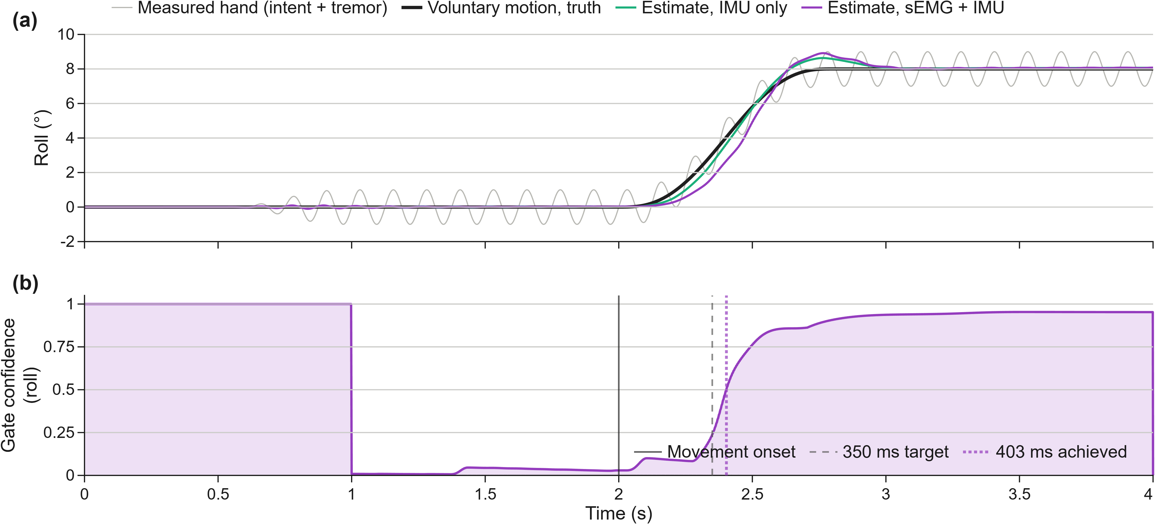
Fig. 3. The fast-reach scenario and the gate's response to it. (a) A 0.8 s voluntary reach superimposed on 8 Hz tremor. The reach is not separable by eye in the measured hand signal, which is what the estimator has to work from; both estimators recover it, the sEMG + IMU estimate lagging slightly. (b) The gate confidence that scales the estimator's intent process noise. The gate is held open during a 1 s warm-up so that it cannot assert an absence of muscle drive before its filters have settled. Against the 350 ms target declared in advance, the gate reaches half confidence 403 ms after movement onset at the seed shown; over the four declared seeds the experiment records 407 ms (404–418 ms).
2) The rate-of-change detector, and a retracted measurement. An earlier revision of this work recommended replacing the amplitude detector with a rate-of-change detector, on an informal observation of a single trace quoted as roughly fourfold earlier detection. Tested properly over three detector families and four corner frequencies, with thresholds derived by the same rule used for the delivered detector and the reach scenario held out, that recommendation does not survive. The rate observable separates the two classes the wrong way round: against a requirement of at least 4:1, the measured separations are 0.69:1 at a 2 Hz corner, 0.27:1 at 4 Hz, 0.14:1 at 8 Hz, and 0.13:1 at 16 Hz. The cause is structural rather than a matter of tuning — the rate of muscle drive is largest for the fastest thing in the signal, and in a tremulous hand that is the tremor. The admissible region of the latency-versus-separation plane is empty. No candidate was adopted and the 350 ms target was not moved; the earlier measurement is recorded as retracted rather than deleted.
3) Real forearm sEMG does not separate both contraction directions. The class separation the fusion depends on cannot be measured on public data, because no public dataset records forearm sEMG together with a measured tremor. What can be measured is voluntary contraction against quiescent rest, which bounds the intent-versus-tremor separation from above. Run through the delivered gate front end on two GRABMyo participants [4], wrist flexion separates as designed — 10.1:1 and 5.1:1, taken as the roll-axis median drive against the resting median — but wrist extension reads 2.5:1 and 0.46:1 by the same statistic. The declared pooled rule is stricter still, taking the worst case across both conditions and both axes, and on that rule the two participants give 0.8:1 and 0.1:1 against a 6.3:1 synthetic figure and a 4:1 requirement. Two mechanisms absent from the synthetic model account for it: a standing DC offset of 7–20 % of a strong contraction's drive in the differential envelope at rest, and genuine agonist/antagonist co-activation of 0.63–0.78. Subtracting the measured resting baseline was tested as a remedy and lifts the pooled ratios only to 1.1 and 1.9 — a real improvement, still far short. Neither mechanism is fixed here, and the synthetic separation figure must be read as optimistic in a way that was not previously visible.

G. Feasibility Study: Recorded Human Tremor

1) Motivation
Every figure in Sections D and E was measured against tremor this project generated itself — sines, chirps and sums of a few sines, which are smooth, stationary, and have a crest factor of 1.414. Real pathological tremor is none of those things. Since no public dataset pairs forearm sEMG with a measured tremor, the muscle signal must remain synthetic; but tremor recordings on their own are plentiful, so there is no reason for the tremor to be synthetic as well. This study replaces it.

2) Method
The tremor input is taken from the PhysioNet tremordb database [1], [2]: index-fingertip velocity recorded by laser transducer at 100 Hz from patients with Parkinson's disease. Every stimulation-off, medication-off record was used — 60 recordings from 14 patients, tremor with neither deep brain stimulation nor L-dopa acting on it, which is the most natural tremor the database contains. All 60 were verified against the published SHA-256 checksums.
Each recording is band-pass filtered over 2–25 Hz, integrated from velocity to displacement, band-pass filtered again to remove the integration ramp, and resampled, with five seconds skipped at each end to exclude filter transients and transducer settling.
Two decisions bound what the study may claim. First, the recordings supply waveform shape only and are amplitude-normalised. They are fingertip translation, whereas the plant input is hand attitude; nothing in the database permits converting one into the other, and assuming a moment arm would present an assumption as a measurement. What transfers is the temporal structure — amplitude modulation, harmonic content, frequency wander, non-stationarity — and that is scale-free. Second, each record is normalised to the RMS of a unit-amplitude sine rather than to unit RMS, so that a recorded scenario and a synthetic scenario of the same nominal amplitude present the same tremor energy; without this the comparison would measure the scaling rather than the waveform.
Amplitude, duration, solver step, sensor seed and scoring window are identical to the synthetic benchmark. For the fourteen primary records a paired synthetic control is also run at that record's own dominant frequency, so the comparison isolates waveform structure from frequency instead of confounding the two.

3) What the Synthetic Model Was Missing
TABLE III. TREMOR INPUT PROPERTIES
Property | Synthetic sine | Recorded tremor
Crest factor, median (range) | 1.414 | 2.77 (1.74–6.26)
Dominant frequency, median (range) | as commanded | 4.48 Hz (2.41–8.41)
Records inside the declared 4–20 Hz envelope | — | 46 of 60

Fourteen records fall below the 4 Hz design floor. Thirteen of those come from the low-amplitude tremor group — subjects receiving stimulation for rigidity or dyskinesia rather than for tremor — whose residual tremor is small enough that the dominant spectral peak reflects low-frequency content rather than a tremor proper. Results are therefore reported both over all 60 records and over the 46 inside the declared envelope, so that a statement about the design brief is not folded into a statement about waveform shape.

4) Results
TABLE IV. SUPPRESSION ON RECORDED TREMOR, 46 IN-BAND RECORDS
Variant | Mean (%) | Worst (%) | Meets 90 % | Attitude RMS (°)
simple_pid | 81.62 | 52.65 | 8 of 46 | 0.2080
ekf_cv (IMU only) | 73.16 | 29.58 | 8 of 46 | 0.3073
ekf_cv_semg | 86.81 | 62.62 | 21 of 46 | 0.1464

TABLE V. PAIRED AGAINST A SYNTHETIC SINE AT THE SAME FREQUENCY
Variant | Synthetic (%) | Recorded (%) | Change (points) | Worst change
simple_pid | 80.94 | 81.07 | +0.13 | −23.22
ekf_cv | 95.50 | 71.71 | −23.79 | −41.29
ekf_cv_semg | 96.11 | 86.57 | −9.54 | −22.94

Fig. 3 shows a representative recording against its RMS-matched sine, and the paired comparison.
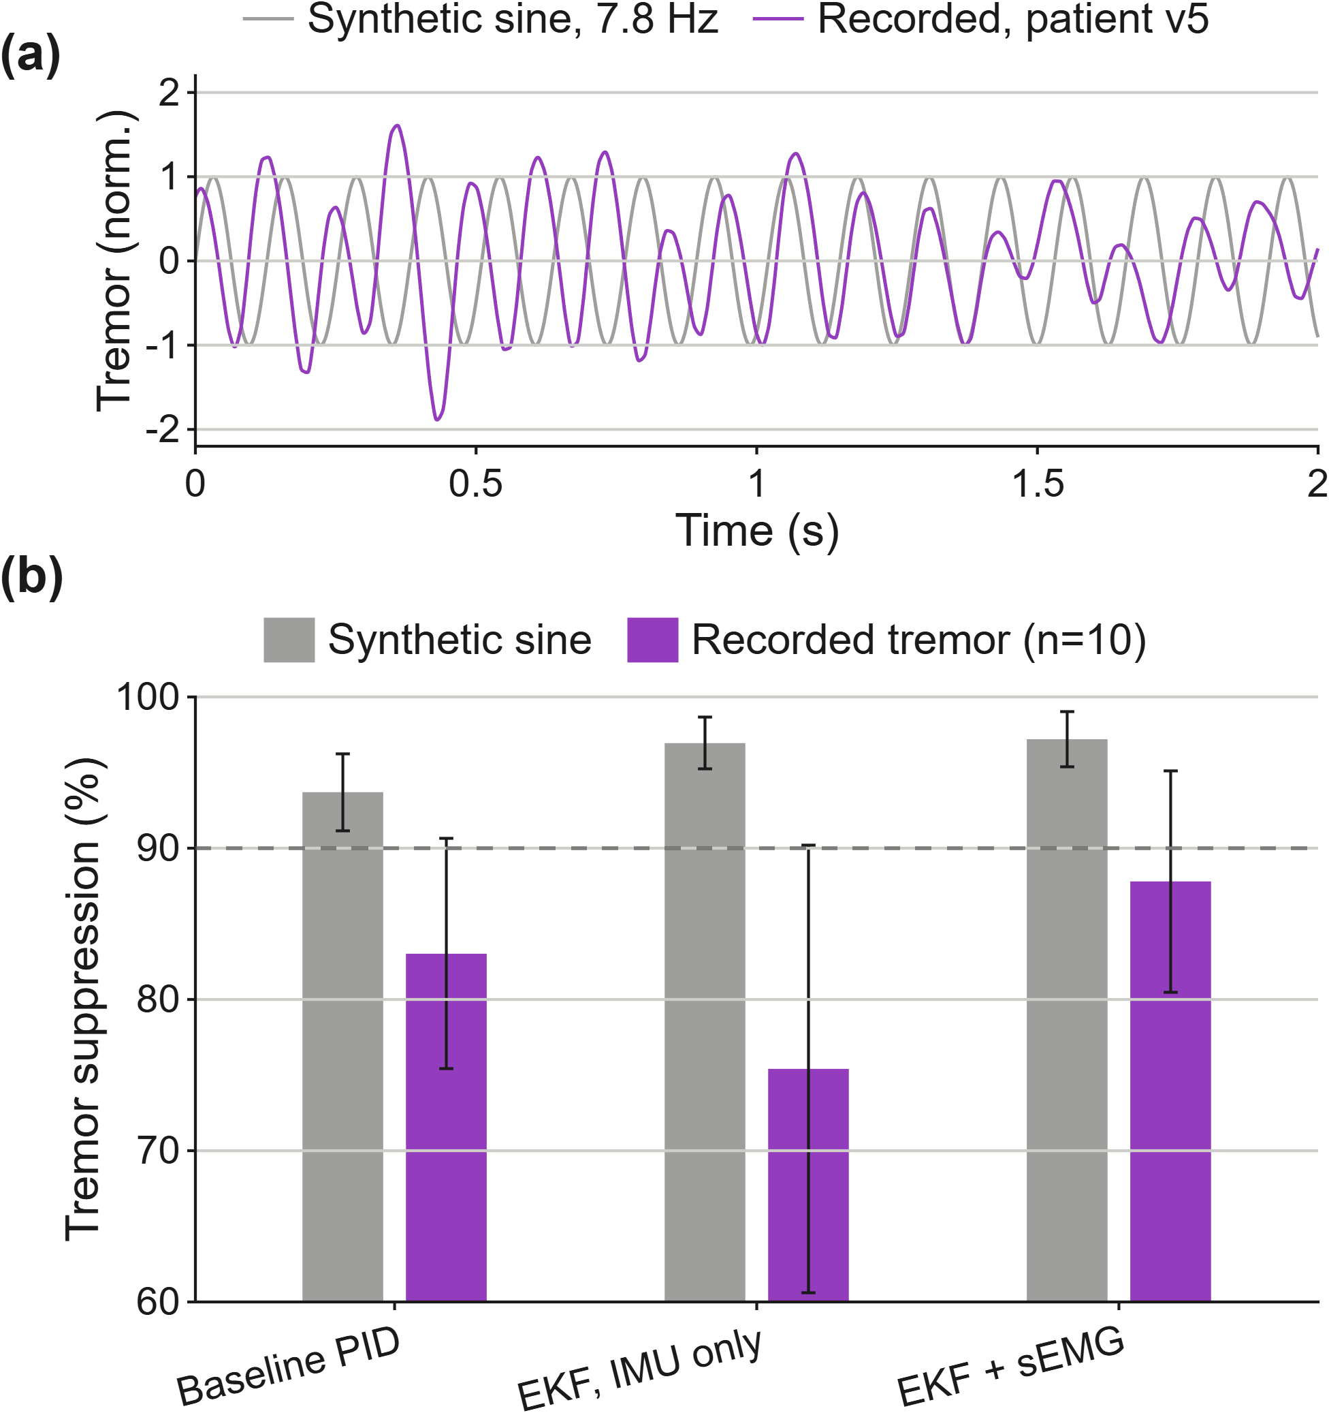
Fig. 4. Recorded human tremor. (a) Two seconds of a conditioned tremordb recording against the RMS-matched synthetic sine at the same dominant frequency. (b) Mean tremor suppression for each controller over the paired in-band records, synthetic against recorded; error bars are one standard deviation across records.

5) Interpretation
Three findings follow, and the first two are unfavourable.
The synthetic benchmark is materially optimistic. The 93.04 % of Table I is a figure for smooth, stationary tremor. Against recorded tremor the delivered controller averages 86.81 % and meets its own 90 % target on fewer than half the records. Table I is not withdrawn — it measures what it says it measures, and it is the basis on which the controller was designed — but it must not be quoted as a figure for real tremor.
The estimator is what degrades, not the plant. The IMU-only estimator loses 23.79 points where the fixed-notch baseline loses essentially none. The explanation is structural: the estimator carries a single-frequency tremor model, and real tremor wanders in frequency and amplitude in a way a sine does not, so the model is mis-specified precisely where the baseline's broad notch chain is indifferent to the difference. This is the same weakness identified in the estimator's design analysis, reappearing under a harder input.
The muscle signal helps most where the estimator is weakest. The margin of the delivered controller over the IMU-only estimator widens from +0.92 points on synthetic tremor to +13.65 points on recorded tremor. This is consistent with the mechanism of Section E: the worse the tremor model fits the data, the more tremor is absorbed into the voluntary-motion state, and the intent gate is what prevents that absorption. On this evidence the argument for fusing sEMG is stronger against real tremor than against the synthetic tremor the design was tuned on.

6) What This Does Not Establish
This is a real-signal robustness test of the control algorithm. It is not a clinical result, and it is not evidence about the sEMG assumptions, which stand exactly where Section F leaves them — the muscle signal remains synthetic throughout and is generated from the same ground truth that drives the simulated hand. The recordings are Parkinsonian rest tremor of the index finger, not postural tremor of the wrist during self-feeding. A single-axis recording drives both controlled axes, the second being a quarter-period-shifted copy. The precise claim supported is narrow: the control algorithm was tested against the recorded temporal structure of real Parkinsonian tremor; its advantage over the IMU-only estimator is larger there than on synthetic tremor, while its absolute performance is materially worse than the synthetic benchmark indicates.

H. Threats to Validity and Reproduction
The principal threats to validity, in order of how much they would change the conclusions, are: the absence of any hardware measurement, which leaves every actuator and flexure parameter unverified; the synthetic muscle signal, which carries the information asked of it by construction and therefore makes every sEMG figure an upper bound; the plant model's lack of hysteresis, creep and backlash; the unmeasured 40 ms electromechanical delay on which the rationale for sEMG rests, taken from the literature [3] rather than measured here; and the fact that a sustained isometric hold would be read as deliberate movement, which is untested and is the safe direction of failure.
Closing these requires one experiment that was out of scope: a short synchronised recording of forearm sEMG and limb motion from a person, alternating rest, tremor and deliberate reaching. Twenty minutes of such data would close four of the six open validation stages and produce the first real measurement of the class separation on which the fusion depends.
All results are reproduced from the repository with:
START_PROJECT('setup') % paths and output folders
START_PROJECT('test') % 17 validation groups
START_PROJECT('benchmark') % Tables I, II and Figs. 1, 2
START_PROJECT('fastmove') % Sections F.1 and F.2
START_PROJECT('realdata') % Section F.3
START_PROJECT('realtremor') % Tables III-V and Fig. 3
START_PROJECT('all') % everything, in dependency order

References
[1] A. Beuter, M. S. Titcombe, F. Richer, C. Gross, and D. Guehl, "Effect of deep brain stimulation on amplitude and frequency characteristics of rest tremor in Parkinson's disease," Thalamus & Related Systems, vol. 1, no. 3, pp. 203–211, 2001.
[2] A. L. Goldberger et al., "PhysioBank, PhysioToolkit, and PhysioNet: components of a new research resource for complex physiologic signals," Circulation, vol. 101, no. 23, pp. e215–e220, 2000.
[3] P. R. Cavanagh and P. V. Komi, "Electromechanical delay in human skeletal muscle under concentric and eccentric contractions," European Journal of Applied Physiology, vol. 42, no. 3, pp. 159–163, 1979.
[4] A. Pradhan, J. He, and N. Jiang, "Multi-day dataset of forearm and wrist electromyogram for hand gesture recognition and biometrics," PhysioNet, v1.1.0, 2022, doi: 10.13026/rzbf-ts96. (GRABMyo.)
[5] E. Rocon, J. M. Belda-Lois, A. F. Ruiz, M. Manto, J. C. Moreno, and J. L. Pons, "Design and validation of a rehabilitation robotic exoskeleton for tremor assessment and suppression," IEEE Trans. Neural Syst. Rehabil. Eng., vol. 15, no. 3, pp. 367–378, 2007.
[6] Y. Bar-Shalom, X. R. Li, and T. Kirubarajan, Estimation with Applications to Tracking and Navigation. New York, NY, USA: Wiley, 2001.
[7] J. A. Gallego, E. Rocon, J. O. Roa, J. C. Moreno, and J. L. Pons, "Real-time estimation of pathological tremor parameters from gyroscope data," Sensors, vol. 10, no. 3, pp. 2129–2149, 2010.
[8] H. J. Hermens, B. Freriks, C. Disselhorst-Klug, and G. Rau, "Development of recommendations for SEMG sensors and sensor placement procedures," Journal of Electromyography and Kinesiology, vol. 10, no. 5, pp. 361–374, 2000.
[9] C. N. Riviere, R. S. Rader, and N. V. Thakor, "Adaptive cancelling of physiological tremor for improved precision in microsurgery," IEEE Trans. Biomed. Eng., vol. 45, no. 7, pp. 839–846, 1998.

